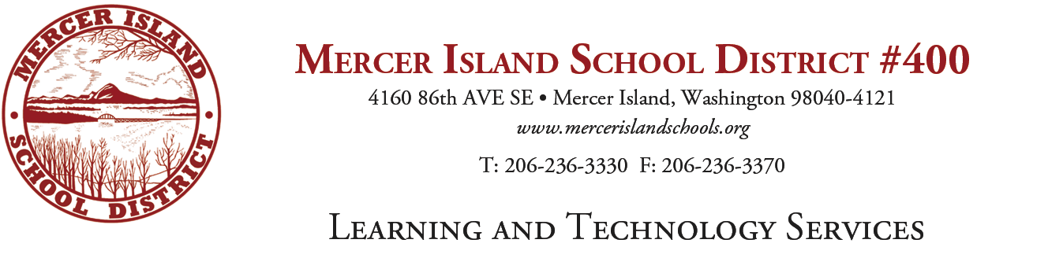
K-5 Writing Adoption Committee
Agenda

- New introductions

- Review of last year’s work
  - Review of literature on writing—we split up articles to increase and confirm our knowledge base. The intention is to do this again.
  - Surfacing of assumptions of the committee—Reviewed the process for our assumptions and the follow up of the norms created from them.
  - Norms created by the team last June—We added to the norms created last June. The team concluded that we needed to have norms and agreements as we move forward. Some were added that connect to the work we will do once we move forward with an adoption.

- Review of our plan for this year
  - Review additional literature on good writing instruction--
  - Review rubric for evaluations – To occur on 12/1/16
  - Evaluate materials—Beginning in 2017 and all of the following items as well.
  - Select finalists
  - View presentations of finalists
  - Make final decision

