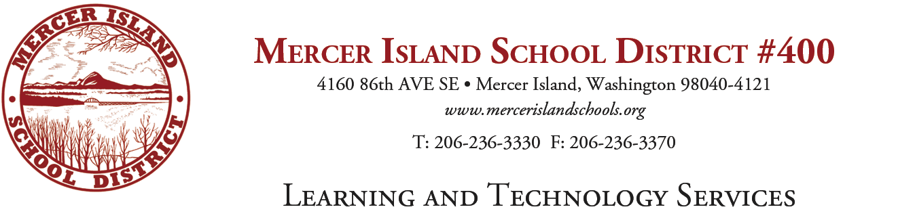
K-5 Writing Adoption Committee
Agenda

- Agree to previous meeting notes
- Rubric review—Teams reviewed for preferences and commented. The following is an order that all agreed to and we will review again at the next meeting.

One team started backwards- Order and language as follows:
- 1- Variety and Language-- Agreed
- 2- Foundational Skills
- 9- Speaking and Listening
- 3- Teacher Resources-- Agreed
- 5- Instructional Practices
- 4-Differentiation
- 6- Assessment
- 8- Professional Development

Next Meeting:

1/12 or 1/23? Preferences?

Landed on 1/23

